雲林縣揚中教育基金會第15屆英語能力競試
I. Picture Questions (10%)
Look at each picture and answer the question.

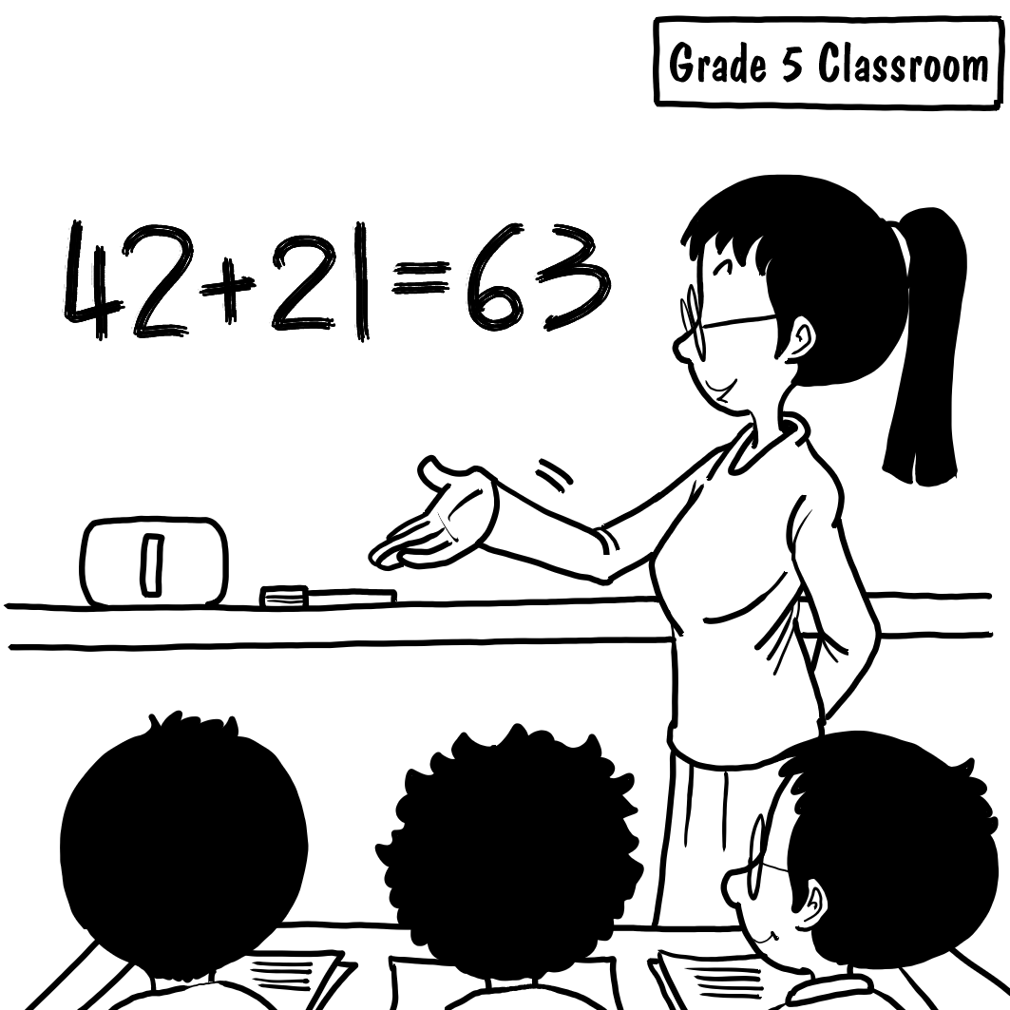
(B) 1. What class are the students in?
(A) English class.
(B) Math class.
(C) Music class.
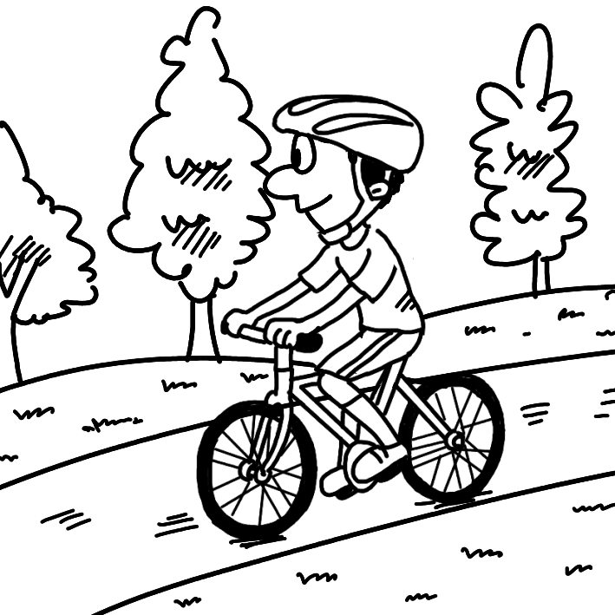
(A) 2. What does Danny like to do in his free time?
(A) Ride a bike.
(B) Play basketball.
(C) Watch TV.

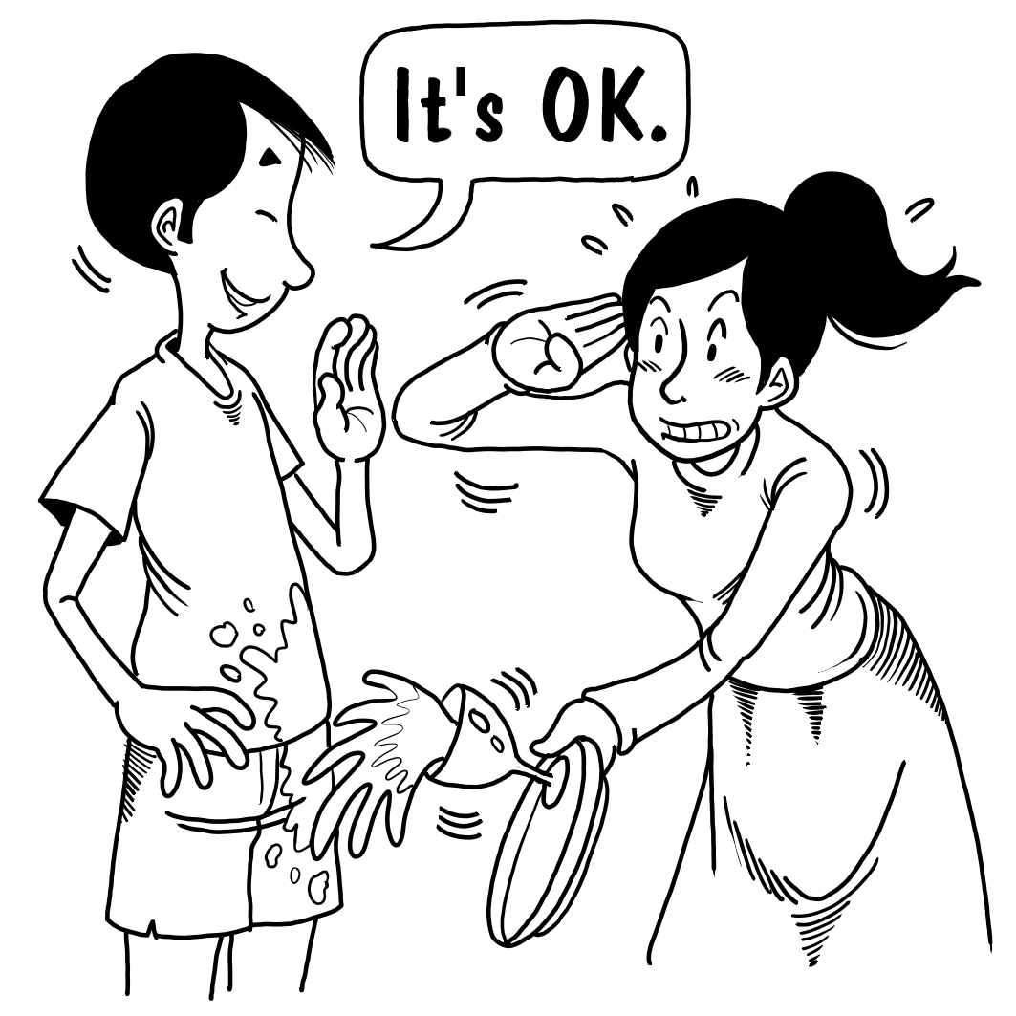
(B) 3. What is the woman saying to the man?
(A) Be quiet!
(B) I’m so sorry!
(C) Hurry up!

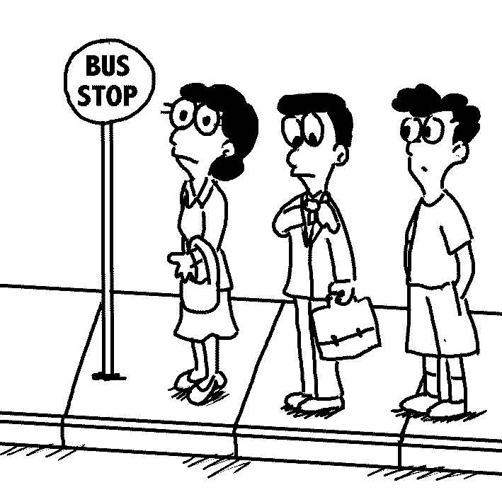
(C) 4. What do we know about these people?
(A) They are riding on the bus.
(B) They are getting off the bus.
(C) They are waiting for the bus.

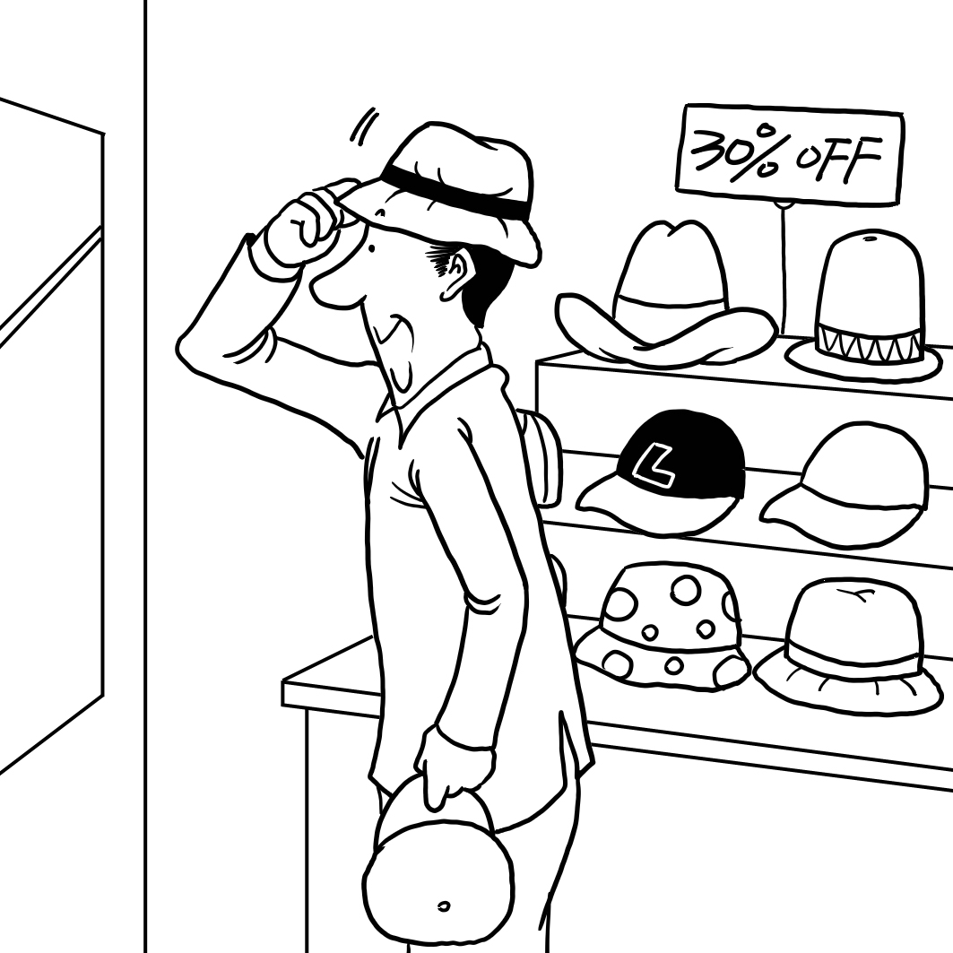
(A) 5. What is the man shopping for?
(A) Hats
(B) Shorts.
(C) Shirts .

II. Best Response Questions (30%)
Listen to the question or statement and choose the best response.

(C) 6. Would you like to see a movie tonight?
(A) OK. How about steak?
(B) Yeah. I like that movie, too.
(C) Sure. Let's see what's on the movie theater.

(A) 7. What do you like to do on the weekend? (p. 39)
(A) I play the piano and ride my bike.
(B) They are both teacher.
(C) I want to be a doctor.

(A) 8. What are you looking at?
(A) There’s a beautiful bird in the tree.
(B) I can’t find my pen!
(C) It’s really windy today.

(B) 9. Where is your cat?
(A) It’s a girl.
(B) She is under the chair.
(C) She likes to sleep on my bed sometimes.

(C) 10. What is your favorite animal?
(A) I have a dog in my house.
(B) I’m afraid of snakes.
(C) I like horses the best.

(C) 11. Helen, can I talk to you now?
(A) No. I don’t have a boyfriend.
(B) Yes. It’s a gift for you.
(C) I’m afraid not. I’m busy.

(A) 12. Leo is too thin.
(A) Yes. He should eat more.
(B) Yes. He should study more.
(C) Yes. He should get some exercise.

(B) 13. Summer is my favorite season.
(A) Yeah. I love the snow.
(B) Not for me. I don’t like hot weather.
(C) Why? Don’t you think it’s too cold?

(C) 14. Hey! You need to hurry.
(A) OK. I’ll slow down.
(B) OK. I’ll do it later then.
(C) OK. I’m coming.

(A) 15. The dog looks thirsty.
(A) Yes. Let’s give it some water.
(B) True. Let’s play with it.
(C) Yeah. Let’s wash it.

(C) 16. Can you help me clean?
(A) OK. It’s on the desk.
(B) That’s fine. You can go.
(C) Sure, what can I do?

(B) 17. That library isn’t open at night.
(A) Yes, it has many books.
(B) Right. It closes at 5 p.m.
(C) Good. Let’s go there tonight.

(B) 18. What’s wrong, David?
(A) There’s nothing wrong with my answer.
(B) I can’t find my keys.
(C) I like apples and oranges.

(B) 19. Linda always wears black clothes.
(A) True. She should wash them.
(B) Yes. It’s her favorite color.
(C) Yeah. They’re too big.

(C) 20. I really worry about David.
(A) Just tell him you are sorry.
(B) Yes, I’m happy for him too.
(C) Why? What happened?

III. Conversation Questions (10%)
Listen to each conversation and answer the question.

(B) 21. M: These flowers are for you. (9-p. 24-7)
F: Oh, thank you!
M: Do you like them?
F: Of course. They are so beautiful.
Q: What does the woman say about the flowers?
(A) They smell good.
(B) They look nice.
(C) They are not fresh.

(B) 22. M: Honey, I’m home. What are you doing?
F: I’m cooking dinner.
M: Wow, that’s a lot of food.
F: I made your favorite dish.
Q: Where is the woman?
(A) She’s in her bedroom.
(B) She’s in the kitchen.
(C) She’s in the bathroom.

(B) 23. M: What date is today?
F: It’s the 13th, Friday.
M: When will be the picnic?
F: It’s tomorrow.
Q: When will they have a picnic?
(A) Friday.
(B) Saturday.
(C) Thursday.
(A) 24. M: I’m so hungry.
F: Let’s go eat.
M: OK. Where should we go?
F: How about McDonald’s?
Q: What does the woman want to eat?
(A) Hamburger.
(B) Fried rice.
(C) Dumpling.

(C) 25. M: What’s your name? (1509-p. 39-17)
F: My name is Sandy.
M: What do you do?
F: I’m a nurse.
Q: Where does the woman work?
(A) At a theater.
(B) In a restaurant.
(C) At a hospital.

IV. Vocabulary Questions (10%)

(B) 26. There is something wrong with my ____. Can I sit down for a while?
(A) shirts
(B) legs
(C) backpacks
(D) shoes

(B) 27. Nancy has to __(27)__ early every day to catch the bus.
(A) watch out
(B) get up
(C) cheer up
(D) fly away

(A) 28. Why does Sarah stop talking to me? Is she __(28)__ with me?
(A) angry
(B) cool
(C) busy
(D) popular

(C) 29. A: Kevin just asked me for my __(29)__ number.
B: Well, I think he likes you!
(A) seat
(B) ID
(C) phone
(D) house

(D) 30. It’s really warm and clear today. Let’s play __(30)__.
(A) much
(B) home
(C) yesterday
(D) outside

V. Cloze (20%)

Questions 31-35

Mary: Mom, can I buy a new skirt?
Mom: But you already have so many.
Mary: I know, but they are __(31)__.
Mom: Oh, OK. Fine.

At the clothing shop

Mom: How about this one?
Mary: It’s cute, but I don’t __(32)__ pink. Can I have this blue one?
Mom: Why not? Go and try it on.
Mom: It looks really nice on you.
Mary: Really?
Mom: Yeah. The mirror (鏡子) is over there. See for yourself.
Mary: Great! I’ll take this one.
Mom: __(33)__ We want this skirt.
Clerk: OK, ma’am.
Mom: __(34)__ is it?
Clerk: Four hundred and fifty NT dollars.
Mom: __(35)__.
Clerk: Thank you very much.

(D) 31. (A) pretty
(B) fat
(C) cheap
(D) old

(A) 32. (A) like
(B) care
(C) have
(D) wash

(B) 33. (A) I’m ready.
(B) Excuse me.
(C) No way.
(D) See you.

(C) 34. (A) How big
(B) How long
(C) How much
(D) How many

(A) 35. (A) Here you go.
(B) Let it be.
(C) Take care.
(D) See you later.

Questions 36-38

(The phone is ringing. Kelly picks it up.)
Kelly: Hello?
Jeremy: Hi, __(36)__ Jeremy. Can I speak to Phil, please?
Kelly: Sure. I will go get Phil. Hold on a second, please.
Phil: Hi, Jeremy. How are you?
Jeremy: I’m doing great. Can you talk right now?
Phil: I can’t hear you very well. There must be something wrong with the
connection (收訊). __(37)__ you call me back in about half an hour
Jeremy: OK. My __(38)__ is 2345-1111.

(D) 36. (A) here is
(B) he is
(C) call me
(D) this is

(C) 37. (A) Are
(B) Do
(C) Can
(D) When

(B) 38. (A) address
(B) number
(C) line
(D) hobby

Questions 39-40

Tina is a junior high school student in Taiwan. Tina thinks Taiwan is a beautiful country. __(39)__ many mountains, trees, and rivers in Taiwan. People here are __(40)__, too. Many foreigners like Taiwan, too. They come here to relax.

(C) 39. (A) There have
(B) There is
(C) There are
(D) There has

(B) 40. (A) terrible
(B) friendly
(C) dangerous
(D) strange

VI. Short Passage Questions (20%)

Questions 41-42

Ted’s Class schedule │Fall 2016
 | Mon | Tue | Wed | Thu | Fri
10:00-12:00 | Chinese | Chinese | English | Math | PE
Lunch Break
13:00-15:00 | Math | PE | Art | English | Math
15:30-17:30 | English | History | Math | Science | Chinese

(C) 41. How long is the lunch break?
(A) Thirty minutes.
(B) Fifty minutes.
(C) An hour.
(D) Two hours.

(A) 42. What does Ted do on Friday morning?
(A) Exercise.
(B) Draw pictures.
(C) Learn something about the past.
(D) Learn something about numbers.

Questions 43-45

Tina is going to be busy all day today. First, she is going shopping for some meat and juice at the supermarket. Then she has to take her sister to the hospital. She will also go to the library. After that, she will meet up with Jane for dinner. Today is really going to be crazy for her.

(D) 43. Who is sick?
(A) Jane.
(B) Tina.
(C) Jane’s sister.
(D) Tina’s sister.

(C) 44. What might Tina buy at the supermarket?
(A) Eggs.
(B) Apples.
(C) Beef.
(D) Milk.

(A) 45. What is Tina going to do before dinner?
(A) Read books.
(B) Meet her friend.
(C) Eat some food.
(D) Go to a doctor.

Questions 46-47
Tom’s To-Do List
Monday – dinner with Mom
Tuesday – study for test (morning);
mail birthday gift to Kim (afternoon)
Wednesday – open bank account
Thursday – big meeting at work
Friday – dentist appointment

(B) 46. When will Tom be in a post office?
(A) Monday.
(B) Tuesday.
(C) Wednesday.
(D) Thursday.

(A) 47. When will Tom meet one of his family?
(A) Monday.
(B) Tuesday.
(C) Thursday.
(D) Friday.

Questions 48-50

Last week, I left a blue shopping bag at the bus stop outside Jenny’s Snack Shop. There are my cell phone, camera, MP3 player, and earphones in the bag.
If you find the bag, please e-mail me at amychen@mailnet.com. I will give NT$1000 to anyone who finds the bag and the things inside it.
Thank you very much!
-Amy

(B) 48. Where did Amy lose her bag?
(A) At Jenny’s Snack Shop.
(B) At a bus stop.
(C) On the bus.
(D) At Jenny’s house.

(A) 49. What is NOT in Amy’s shopping bag?
(A) Her wallet.
(B) Her camera.
(C) Her MP3 player.
(D) Her cell phone.

(D) 50. David finds Amy’s bag. What should he do?
(A) Call her.
(B) Go to her house.
(C) Take it to Jenny’s Snack Shop.
(D) E-mail her.

